DM HW3 – Problem 1
First, listen to this podcast from Planet Money. Then use your knowledge of statistical learning to answer the following questions.
- Why can’t I just get data from a few different cities and run the regression of “Crime” on “Police” to understand how more cops in the streets affect crime? (“Crime” refers to some measure of crime rate and “Police” measures the number of cops in a city.)
Answer: I high correlation and “significant” regression between police and crime does not tell you anything about causality. First, these variables are endogenously related (you may increase police to respond to more crime), so the direction of causality (if any) is unclear. Second, cities are heterogenous in their characteristics (income, unemployment, density, cost-of-living, etc.), so aggregating data from many cities can blur actual trends. In order to isolate a causal link between “more cops” and “crime,” you need to remove the endogeneity between them.
- How were the researchers from UPenn able to isolate this effect? Briefly describe their approach and discuss their result in the “Table 2” below, from the researchers' paper.
Answer: The researchers at UPenn used a reduced-form instrumental variable analysis (simply regress the instrument on the outcome) technique to estimate the implied exogenous causal effect of “more cops” on “crime.” They cleverly used “terror alerts” as an exogenous instrument to do so. “Terror alerts” are correlated with “more cops” (since there is increased police presence on terror alert days), but they are independent of the “crime.” Therefore, you can roughly estimate the exogenous effect of “more cops” on crime using only the information contained in the correlation between “more cops” and “terror alerts” by regressing “crime” on “terror alerts” because this information is exogenous to the outcome (“crime”).
The results in Table 2 show that daily crimes decrease by about 7 crimes when there is a terror high alert day, versus when there is not such an alert. Since high alert days are correlated with more police presence, we can interpret this as better evidence of a causal effect of “more cops” on lowering “crime.” In the second regression, the effect controls for metro ridership, but here is still a large and significant effect (about 6 less crimes per day).
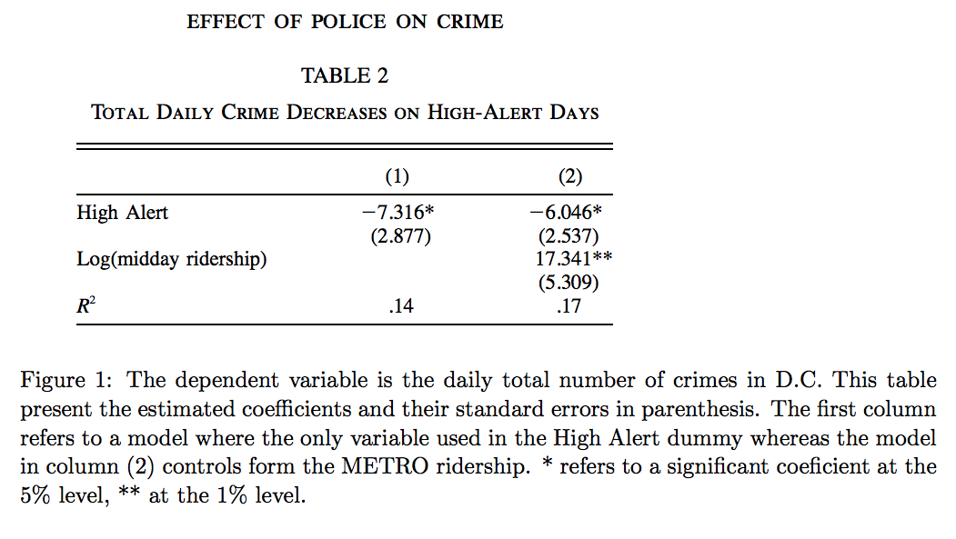
- Why did they have to control for Metro ridership? What was that trying to capture?
Answer: The authors controlled for metro ridership because on terror alert days, many streets are closed off, forcing more people to commute underground. The effect seems to be an increase in crime, maybe because it is easier to get away with crimes in the metro stations than on the street. Since metro ridership is a driver of crime during high alert days, it is necessary to control for this affect in order to better isolate the effect of “more cops” on “crime.”
Controlling with metro ridership captures the portion of crime reduction that is solely attributed to increased police presence, and separate from the portion of crime reduction that is attributed to increased metro ridership.
- Below I am showing you "Table 4" from the researchers' paper. Just focus on the first column of the table. Can you describe the model being estimated here? What is the conclusion?
Answer: The model in the first column uses interactions between the whether it is a terror high alert day and whether the crime is occurring in the national mall district (or other districts). This is done using two interaction terms. The national mall experiences much more police increase on high alert days because most of the important assets the police need to protect are located in the national mall district (monuments, politicians, etc). This more nuanced analysis tells us that crime is reduced more in the national mall district than in other districts if it is a high alert day. This makes sense, given the higher police presence in that district. Crimes are reduced by about 2.6 in the national mall on high alert days versus only by 0.57 in other districts on high alert days. The conclusion is that there is interactive information in police presence from high alert days and the districts in DC in terms of an effect on crime. The effect of high alert days (police presence) on crime varies by district, and the more police presence in a district there is (like in the national mall), the lower the crimes will be.
